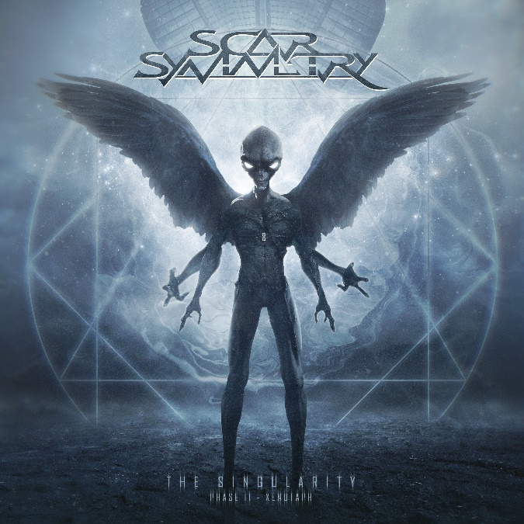

SCAR SYMMETRY
‘The Singularity (Phase II – Xenotaph)’

OUT: June 9th 2023
Roberth Karlsson | vocals  Lars Palmqvist | vocals  Per Nilsson | vocals, guitars, bass, keyboards  Benjamin Ellis | guitars  Henrik Olsson | drums | Scarsymmetryofficial.com  Facebook.com/scarsymmetry  Twitter.com/scarsymmetry  Instagram.com/scarsymmetry

In the beginning, there was a vision of the future. Nearly two decades on, SCAR SYMMETRY are still light years ahead of the competition. It’s time for Phase II…

Formed in Sweden in 2004, SCAR SYMMETRY were a unique proposition from the start. Although clearly owing a debt to the pioneering melodic death metal bands of the ‘90s, guitarist Per Nilsson and his comrades were walking their own evolutionary path. As showcased on 2005 debut Symmetric In Design, the band were driven by fervently progressive and proudly melodic instincts, infusing their often brutal riffs and arrangements with wild, futuristic atmospherics, and sublime, emotional melodies that always hit their targets with ruthless precision.

As SCAR SYMMETRY moved forward, their music continued to evolve in tandem. They joined forces with Nuclear Blast Records for 2006’s breakthrough opus Pitch Black Progress (2006), and have since amassed an extraordinary catalogue of forward-thinking but irrevocably crushing modern metal. From the glossy, hyper-melodic barrage of Holographic Universe (2008), to the immaculate thunder of The Unseen Empire (2011), the Swedes have blown minds and enhanced their reputation with every artistic step.

“I feel that every album we’ve done has been a reaction to the previous one,” says Per. “The first album we ever did was pretty rough, production-wise. On the next one we tried to write a little bit more complex songs, and then on Holographic Universe we really wanted to make something super produced and have songs that were almost radio-friendly. After that we had some turmoil, parting ways with our singer. But finally we got our new singers and then we just wanted to do something different, so it became rougher again but more progressive and more radio-friendly too!”

Every legacy is allowed to take a pause, and SCAR SYMMETRY have been conspicuous by their absence since concluding touring in support of 2014’s astonishing, cosmic odyssey The Singularity (Phase I - Neohumanity). The first in a planned trilogy, the album was widely praised for the sheer audacity of Nilsson’s still-mutating vision. In 2023, SCAR SYMMETRY unveil the second chapter in this intricate, intergalactic saga: The Singularity (Phase II - Xenotaph). Harder, darker, more complex and more joyously progressive than ever, it is more than worth the nine-year wait.

“For me personally, in 2011, when Jonas [Kjellgren] left the band, that was huge turning point. Him and I used to co-write everything. So it became that Phase I was the first album where I wrote all the music, played all the guitars and mixed and mastered everything, and I didn’t have to run my ideas through anybody else. I guess now I’m the boss of the whole playground, and I decide how we’re going to play! [Laughs]”

Per Nilsson cheerfully admits that creating a follow-up to Phase I took longer than expected because, not unreasonably, he simply had other things to do, including touring the world with Meshuggah, as stand-in for the temporarily absent Fredrik Thordendal. But once he returned to the creative process, the sci-fi metal kaleidoscope quickly began to spin again.

“Lyrically, we had a synopsis for all three parts of the trilogy, even before writing a single note,” explains Per. “So we had the storyline, and I had an idea for what each album would be, especially the first and the second ones – the third one is still a little bit in flux! But the first one was supposed to be very melodic and upbeat. The second one was supposed to be darker, and leaning more towards that side of what we do. It may sound cheesy, but I think of it a little bit like the original Stars Wars trilogy. The second part, The Empire Strikes Back, is a bit darker and heavier, and it goes in a different direction.”

As with its acclaimed predecessor, The Singularity (Phase II - Xenotaph) was created almost entirely by Per Nilsson alone. Ensconced in his home studio, colossal flights of brutal fancy like explosive opener Chrononautilus and the bewildering melo-death monolith of Scorched Quadrant were steadily pieced together, providing vocalists Lars Palmqvist and Roberth Karlsson with the most vivid and cinematic of backdrops. One thing that is immediately apparent, as Phase II clicks into gear, is that this is the most brutal record SCAR SYMMETRY have ever made.

“The only difference for this album is that we now have a second guitar player, Ben Ellis, who contributes with leads,” notes Per. “But there is much more brutal and heavy stuff on this one. We’ve always had it, there’s just more of it now! It’s also that the first half of the album is tilted towards that, but it evens out a little bit as the album progresses. I chose to start the album off with Chrononautilus, which is going to be the second single. It starts off with that really fast blastbeat. When people hear it, I want them to say, ‘Holy shit!’ [Laughs].”

Just as the music on The Singularity (Phase II - Xenotaph) is as distinctive and destructive as anything out there, the fantastical, futuristic narrative that runs through it elevates the whole enterprise (pun intended) to an even higher plane of excellence. Begun on Phase I, this continuing story of humanity’s battle with the murderous neo-humans hits its bloody stride during Phase II: an anthology of tales from days of war…

“On the first album, we present the scenario, the universe for our story,” explains Per. “Mankind has become so technologically advanced that we have neo-humans - humans that have been upgraded. We also have the ‘artilects’: the artificial intellects. The neo-humans can upgrade themselves, and that is something reserved for the elite. The masses that are poor and who don’t have access to that, they start to rebel. They see that there is a threat behind this technology. Phase I ends with the Technocalyptic Cybergeddon, a full-on war. So the second album tells the story of that war. There is a race of ultra-terrestrials that have been watching and sometimes meddling in human affairs for millennia. They show up and they are standing on the side of the unmodified people. When all hope was lost, suddenly they appear and they even things out, so it’s a fair fight!”

Now that the world has largely woken from its Covid-induced stupor, Per Nilsson is looking forward to fully reactivating SCAR SYMMETRY and taking the dramatic, pulverising events of Phase II to the people. Faithful to their original masterplan, these kings of metal’s celestial frontier are still way ahead of the game.

“Yeah I think that’s right. Striving to be unique, I think that’s what an artist should do,” Per concludes. “You’re creating that something that’s missing, that’s not available to you. So you have to make it yourself…or at least we’re stupid enough to try! [Laughs]”

